Chapter 5: Discussion
Economic Crisis Prediction: Improving the Trade-off Between Interpretability and Statistical Accuracy in ML-Enhanced Crisis Prediction Models

5.1 Overview of Findings
This chapter synthesises the results reported in Chapter 4, situates them within the broader early-warning system (EWS) literature, and draws out the implications for research design, practical application, and the theoretical limits of machine learning-based crisis prediction. Five interlocking findings define the contribution of the augmented analysis, the fifth of which — the EBM interpretability benchmark — is the most theoretically significant addition relative to the original study.

The first finding is a negative one: extending macro training history from the original 2003–2020 panel to a 1989–2020 panel spanning multiple pre-GFC crisis episodes does not resolve the EWS generalisation problem. M2 trained on the extended panel achieves AUROC 0.481 in strict temporal validation — below the random classifier threshold — indicating systematic failure under genuinely prospective evaluation. The result advances beyond the original analysis by demonstrating that the failure is not an artefact of short training data: even with fifteen additional years of macro history including the Nordic crisis cluster, Japan 1997, and further episodes, the model does not generalise prospectively to the GFC. The regime discontinuity between earlier crisis types and the GFC is structurally too large for aggregate macro features to bridge. This finding implies that the standard EWS paradigm, which assumes a single stable mapping between macro-financial indicators and crisis risk, is fundamentally misspecified in the presence of heterogeneous crisis-generating mechanisms.

The second finding concerns the role of sentiment augmentation. Within the Stage 2 cross-sectional evaluation — the 2007 GFC episode specifically — M3 achieves AUPRC 0.411 against M2-matched’s 0.343, a directional gain of 6.8 percentage points. However, the bootstrap 95 per cent confidence interval spans zero in both the original and augmented designs, all auxiliary statistical tests find no significant relationship between sentiment and crisis outcomes, and SHAP attribution shows that individual sentiment feature rankings are unstable across specifications. The directional AUPRC gain is best characterised as a sample-specific pattern within the GFC cross-section rather than evidence of a generalisable predictive channel.

The third finding concerns the EBM interpretability benchmark. M2.5, the Explainable Boosting Machine trained on the same 41 macro features as M2, appears to achieve higher point estimates than both M2 and M3 within the expanding-window evaluation setting (Stage 1 AUROC 0.753 versus M2’s 0.636; Stage 2 AUPRC 0.532 versus M3’s 0.411), while providing natively interpretable shape functions that require no post-hoc attribution. These expanding-window metrics are subject to the same evaluation constraints as all other models and cannot be taken as evidence of superior generalisable predictive performance. The theoretically significant finding is not EBM’s point estimates but its prospective collapse: in Split B strict temporal validation, EBM achieves AUROC 0.333 — substantially below M2’s 0.481 and below random. This result directly confronts the implicit assumption that interpretable models might be more robust by virtue of their simpler representations. The opposite is observed: EBM’s higher representational flexibility causes it to overfit the regime-specific training distribution more aggressively than Random Forest, producing a worse prospective failure. The central theoretical implication is that the failure of machine learning-based EWS is not a consequence of model opacity — removing opacity through EBM makes the failure more severe, not less, because the underlying cause is non-stationarity in the data-generating process, not a limitation of any particular model class.

The fourth finding concerns the ensemble extension. E1-EBM, defined as the equal-weighted average of M2-matched and EBM M2.5 out-of-sample predicted probabilities, achieves AUROC 0.955 and Brier Score 0.056 — the best calibration of any model or ensemble in the Stage 2 evaluation — while E1-Orig (M4, the original M2-matched and M3 ensemble) achieves comparable AUPRC (0.440 versus E1-EBM’s 0.433) but slightly worse Brier (0.057). The ensemble results are subject to the same single-episode evaluation constraint as their constituent models.

The fifth finding is the crisis type discrimination result from the 2007 cross-sectional ranking under E1-EBM. The ensemble assigns a mean probability of 0.695 to countries whose 2007–2008 stress is characterised as fundamentally credit-boom driven, against 0.395 for contagion-driven cases and 0.325 for countries that experienced no systemic event. Sweden is reclassified as a contagion crisis following confirmation from JST Macrohistory Database R6 that banking crisis onset occurred in 2008 (target_h2 = 1 in 2007), revising the original group counts to Fundamental n = 9, Contagion n = 5, No crisis n = 4. This stratification, whilst based on qualitative crisis type annotation and confined to a single year, indicates that the model’s macro features carry mechanism-specific signal.

Together, these five findings indicate that model uncertainty, feature instability, and the absence of causal structure are manifestations of the same underlying issue: non-stationarity in the crisis-generating process across regimes. Taken together, they demonstrate that the failure of early-warning systems is not primarily a function of model choice, feature design, or data availability, but of a deeper structural instability in the mapping between predictors and crisis outcomes across regimes.

5.2 The EBM Interpretability Benchmark: What Native Transparency Reveals

The introduction of M2.5 (EBM) represents the most theoretically significant extension of the original study. Its contribution is not the performance metrics — which are subject to the same evaluation constraints as all other models — but what its shape functions reveal about the structure of the learning problem.

Because EBM’s shape functions are the model itself rather than a post-hoc approximation, any instability observed in them must reflect a property of the data-generating process rather than an artefact of the attribution method. The shape function analysis (Section 4.7.3) confirms this directly: the learned feature-risk mapping is regime-dependent at every lag horizon examined. For term spread at lag three — the highest-ranked EBM feature (native importance 1.717) — the pre-GFC and GFC-inclusive models produce qualitatively distinct shapes rather than scaled versions of each other, with the two curves crossing. The same feature value is associated with reduced crisis risk under one regime-specific representation and increased risk under the other. For credit features, the pre-GFC model assigns near-zero contributions (no crisis events from which to identify an association) while the GFC-inclusive model assigns increasingly negative contributions at high credit values. This instability is not an artefact of SHAP approximation; it is a direct, readable property of what the model has learned.
The implications extend beyond the specific features. The instability of EBM shape functions confirms that the mapping from macro-financial indicators to crisis risk is not invariant across time — violating the core assumption underlying all static EWS models. This places crisis prediction within the broader class of non-stationary learning problems, where models trained under one data distribution cannot be expected to generalise when the underlying process evolves. Early-warning systems are therefore not merely empirically limited in their generalisation; they are conceptually misaligned with structural break environments, where the data-generating process evolves faster than any static model can adapt.

The convergence between SHAP attribution on M3 and EBM native importance strengthens this conclusion while preventing overinterpretation. Both methods independently identify term_spread_lag3_dm as the dominant signal, and Granger causality tests find this feature significant in 5 of 14 countries at lag three (United Kingdom p = 0.0016, Netherlands p = 0.0028, Italy p = 0.0092, Japan p = 0.0151, Germany p = 0.0305). However, agreement across methods reflects a shared sample-specific correlation structure within the GFC cross-section — not causal invariance across regimes, which the shape function instability directly refutes. The panel logistic sign reversal — lag-one term spread coefficient β = −0.646 (p = 0.004) against lag-three coefficient β = +0.630 (p = 0.003) — provides parametric confirmation that the relationship is non-monotonic and therefore cannot be represented by any model that treats it as linear.

5.3 The Ensemble as a Response to Model Uncertainty

The ensemble extensions operationalise the insight from Holopainen and Sarlin (2017) that in small-sample, crisis-concentrated evaluation settings, combining predictions across models with different architectures is preferable to selecting a single best performer. Equal weighting is used throughout: any performance-weighted scheme that derives weights from the same out-of-sample pool used for evaluation is circular, and given the similar AUROCs of the component models, the equal-weight and AUROC-weight schemes are numerically indistinguishable.
The disagreement analysis provides the substantive justification. The Pearson correlation between M2-matched and EBM predicted probabilities is 0.844 — substantial shared signal without redundancy. Mean absolute disagreement at crisis observations is 0.348, against 0.125 at non-crisis observations — a ratio of 2.8:1 — meaning the ensemble’s moderating effect is strongest precisely at the highest-stakes observations.
This is the condition Holopainen and Sarlin (2017) identify as the primary motivation for ensemble averaging.
One notable feature of the E1-EBM result is that it achieves lower AUPRC (0.433) than EBM alone (0.532), because averaging with M2-matched (AUPRC 0.343) pulls the combined precision-recall performance below EBM’s individual level. The Brier Score of 0.056 for E1-EBM — the best of any Stage 2 configuration — is the more robust metric of ensemble benefit. Where the evaluation objective is producing well-calibrated probability estimates for policy thresholds, the ensemble is preferable; where the primary concern is ranking crisis countries within a known episode, EBM alone achieves higher point estimates within the constrained evaluation setting.

5.4 Crisis Heterogeneity and Model Scope
A structural limitation of all model designs in the EWS literature, including the present analysis, is that crisis target variables derived from banking crisis chronologies are outcome-based rather than mechanism-based. The Laeven and Valencia (2020) chronology records when a systemic banking crisis occurred but makes no distinction between crises driven by domestic credit-boom dynamics, those transmitted through contagion channels, and those triggered by exogenous shocks. Training a model on this undifferentiated label implicitly assumes that the same set of macro and sentiment features is relevant across all crisis types — an assumption that the evidence in this chapter consistently refutes.

Four crisis mechanisms are relevant to the 18-country panel and 1989–2020 evaluation window. Fundamental crises, in which domestic imbalances — credit expansion, asset price inflation, current account deterioration — accumulate over multi-year horizons before triggering systemic stress, are the mechanism that EWS macro features are designed to detect.
The Nordic crisis cluster of 1991, the Japanese episode of the late 1990s, and the GFC credit-boom dynamics in the United States, Ireland, and Spain all broadly fit this pattern. Contagion crises, in which stress originates externally and propagates through financial linkages without corresponding domestic imbalance, constitute a different mechanism: Germany, Belgium, and Switzerland in 2007–2008 experienced stress primarily through exposure to US asset-backed securities rather than domestic credit cycles. Speculative attack episodes, such as the ERM crisis of 1992, represent a third mechanism: self-fulfilling expectations against a fixed exchange rate peg can produce crisis even when domestic fundamentals are sound (Obstfeld, 1996). Exogenous real shocks constitute the fourth type, of which the COVID-19 shock is the most recent example. The 2020 observation is appropriately excluded from the crisis chronology on the grounds that it does not satisfy Laeven and Valencia’s systemic banking crisis criteria.
The 2007 cross-sectional ranking under E1-EBM provides qualified empirical evidence of mechanism-specific discrimination. The mean E1-EBM probability for fundamental crisis countries (0.695, n = 9) substantially exceeds both contagion-driven cases (0.395, n = 5) and the no-crisis group (0.325, n = 4). Group counts reflect the reclassification of Sweden from No crisis to Contagion following confirmation from JST Macrohistory Database R6 that banking crisis onset occurred in 2008 (target_h2 = 1 in 2007). This stratification is coherent with the model’s design: macro features capturing credit conditions, interest rate dynamics, and housing price trends carry more signal for domestically generated imbalances than for externally transmitted stress. The corresponding finding for M4 in the original analysis (fundamental mean 0.599, contagion 0.281) shows the same directional ordering, consistent across both ensemble specifications.

Two country-level results warrant explicit discussion. Sweden (E1-EBM probability 0.783, rank 5) registers as a true positive: the JST Macrohistory Database R6 records banking crisis onset in 2008, with target_h2 = 1 in 2007. Sweden’s elevated credit growth and asset price dynamics in the 2004–2006 period are consistent with precursor conditions for a fundamental crisis, and the model correctly assigns a high probability on that basis. The crisis mechanism, however, was contagion from international markets rather than domestically generated imbalance — an important qualification addressed in Section 5.4.1. The United Kingdom (E1-EBM probability 0.171, rank 15, fundamental crisis) is the most prominent false negative. Its 2007–2008 stress arose through a mechanism that the feature set is not designed to detect, a scope condition examined in detail in Section 5.4.1. Both cases illustrate the limits of the macro precursor approach and are consistent with the crisis heterogeneity argument developed above.

5.4.1 Feature-Level Evidence: Spain, Sweden, and the United Kingdom
The 2007 cross-sectional ranking provides the basis for a structured feature-level case study across three countries that span the range of model outcomes: Spain (correct hit; E1-EBM 0.810†), Sweden (true positive; E1-EBM 0.783), and the United Kingdom (false negative; E1-EBM 0.171). Examining the macro feature values that the model observed for each country in the 2004–2006 period — the lagged window that feeds the 2007 prediction — illustrates both the discriminatory logic of the EBM and the scope conditions under which it fails.

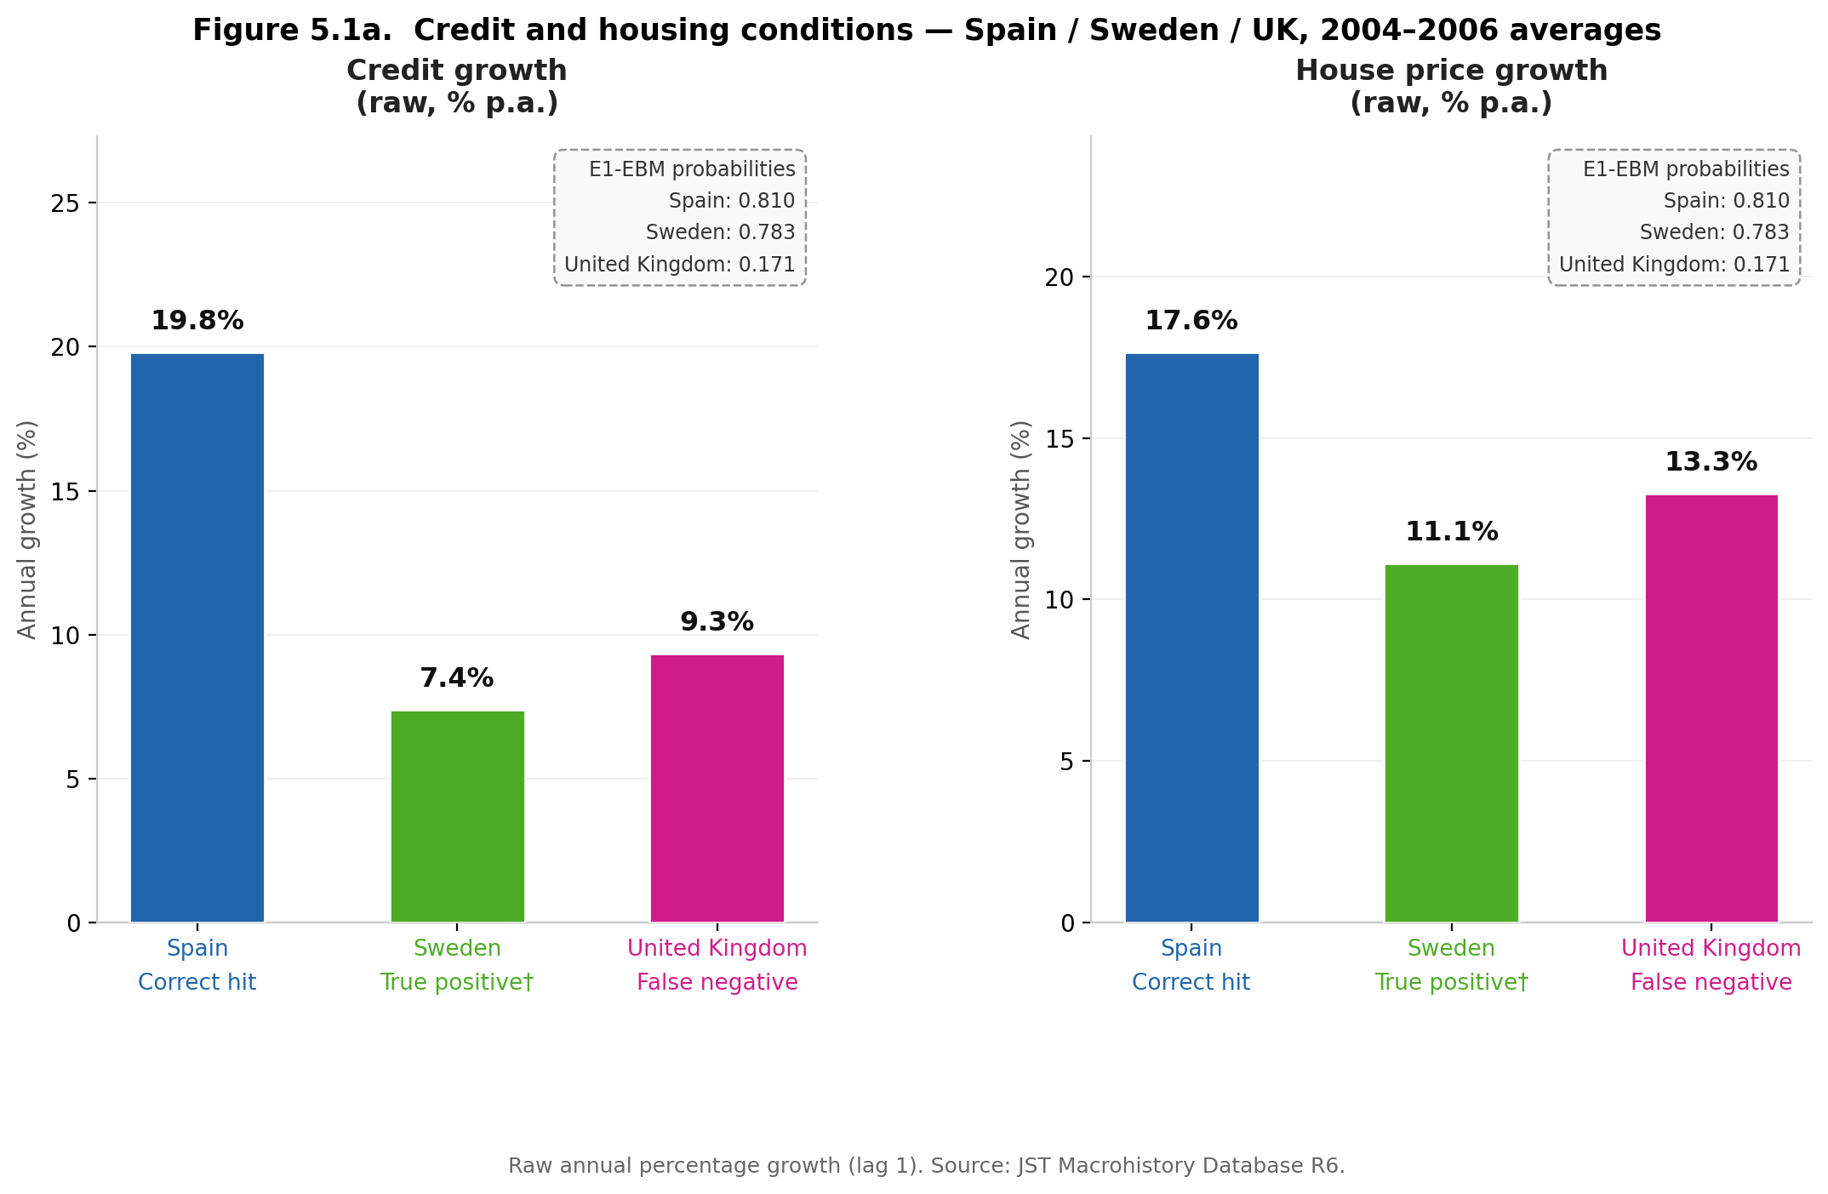

Figure 5.1a presents credit and housing conditions averaged over 2004–2006. Spain’s credit growth of 19.8 per cent per annum and house price growth of 17.6 per cent are consistent with the classic pre-crisis domestic boom pattern: a prolonged phase of credit expansion accompanied by asset price appreciation that EWS macro features are explicitly designed to detect (Schularick and Taylor, 2012). The EBM shape function for credit features assigns increasing crisis probability at elevated credit growth values, and Spain sits well into the high-risk segment of that function. Sweden’s credit growth of 7.4 per cent and house price growth of 11.1 per cent are moderate by comparison and do not signal domestic imbalance accumulation at the same scale. That the model assigns Sweden a high probability (0.783) reflects that Sweden’s term spread and short-term rate deviations — presented in Figure 5.1b — partially overlap with Spain’s: the yield-curve and monetary accommodation signals are not mechanism-specific and do not discriminate between domestic boom and contagion exposure.

The United Kingdom’s false negative is more precisely characterised as a scope condition than a model error. The feature set captures asset-side dynamics — the pace of credit extension, house price appreciation, and macro-financial conditions — but the UK’s 2007–2008 stress originated on the liability side of bank balance sheets. UK institutions had funded expanding mortgage books predominantly through short-term wholesale markets rather than stable retail deposits; when confidence in US asset-backed securities collapsed, the interbank market seized and those funding structures became non-viable. The model’s inputs — credit growth of 9.3 per cent and house price growth of 13.3 per cent — are consistent with moderate expansion rather than a domestic boom, and the EBM correctly assigns a low crisis contribution at those feature values. The crisis that followed was not preceded by the kind of asset-side imbalance accumulation that the feature set is designed to detect. This does not constitute model failure in the usual sense; it reflects that the macro precursor approach has legitimate scope limits when the crisis mechanism operates through funding-channel fragility rather than credit-cycle excess.

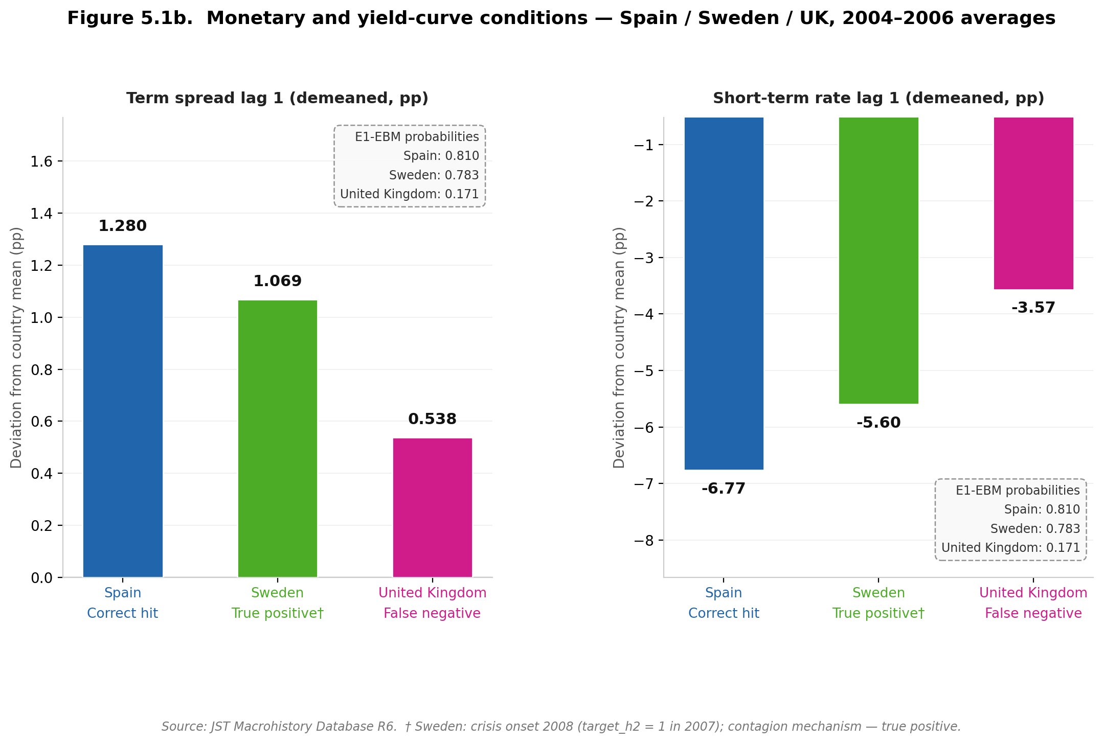

Figure 5.1b presents the monetary and yield-curve conditions, expressed as deviations from each country’s expanding historical mean at lag 1. All three countries display term spreads above their historical averages (Spain 1.280 pp, Sweden 1.069 pp, United Kingdom 0.538 pp) and short-term rates substantially below their historical averages (Spain −6.77 pp, Sweden −5.60 pp, United Kingdom −3.57 pp). The directional pattern is consistent across all three cases: highly accommodative monetary conditions relative to each country’s own history, combined with steepened yield curves, reflect the shared low-rate environment of the mid-2000s rather than country-specific imbalance. This limits the discriminatory power of monetary and yield-curve features at the cross-sectional level: they contribute to elevated aggregate crisis probabilities across the sample but do not differentiate Spain’s domestic credit boom from Sweden’s contagion exposure or the United Kingdom’s funding-channel vulnerability.

The contrast between the two figures is itself informative. In Figure 5.1a, Spain is visually distinct: its credit and house price growth rates are approximately two to three times those of Sweden and the United Kingdom, placing it well into the high-contribution segment of the EBM’s credit shape function. In Figure 5.1b, the three countries are broadly similar: all show substantially negative short-term rate deviations and positive term spread deviations relative to their own histories. The monetary and yield-curve features therefore contribute to elevated aggregate probabilities across the sample but carry little cross-sectional discriminatory power. Taken together, the two panels make visible what would otherwise require post-hoc attribution to establish: the model’s crisis signal is concentrated in credit-cycle dynamics, its errors have identifiable mechanistic causes rather than being randomly distributed across the sample, and the feature-level evidence is legible directly from the inputs. This is precisely the kind of transparency that EBM’s native interpretability is designed to provide — and it arrives without the approximation error inherent in SHAP decomposition applied to a non-linear model.

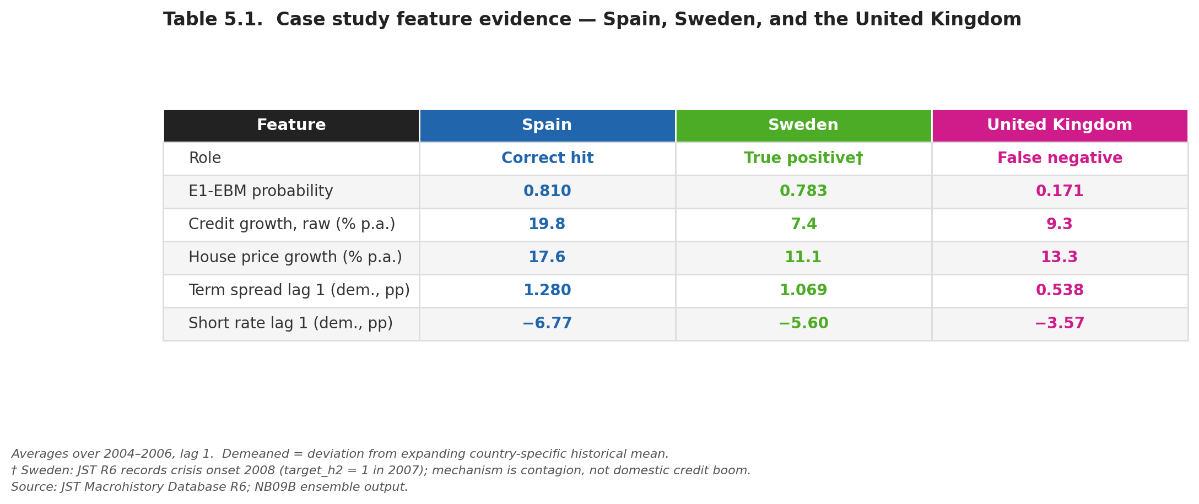

Spain’s E1-EBM probability in the 2007 cross-section is 0.810 (rank 2), taken from the NB09B ensemble output. Sweden’s banking crisis onset is recorded as 2008 in the JST Macrohistory Database R6 (target_h2 = 1 in 2007); the crisis mechanism was contagion from international markets rather than domestic credit accumulation. All feature values are averaged over 2004–2006 at lag 1; demeaned values represent deviations from the expanding country-specific historical mean.

5.5 Implications for Early-Warning System Design

Four practical implications follow from the augmented analysis, stated with appropriate caution given the evaluation constraints throughout Chapter 4.

First, extending training history is necessary but not sufficient for prospective EWS performance. The augmented Stage 1 analysis demonstrates that including fifteen additional years of crisis history does not resolve the generalisation problem. The dominant constraint on EWS performance is regime heterogeneity — models trained on one type of crisis precursor pattern do not generalise to structurally different episodes — rather than training data length per se. An operational EWS would require either a regime-classification layer that identifies the current crisis type before applying model predictions, or a portfolio of models each calibrated to a specific crisis mechanism, rather than a single general-purpose classifier.

Second, interpretable non-linear models such as EBM offer a distinct capability that black-box models cannot provide: direct observation of whether the learned feature-risk relationships are regime-stable. The shape function instability documented in Section 4.7.3 converts what would otherwise be an opaque model failure into a legible, regime-specific misspecification. In a policy context, this matters: a regulator who can see that the model’s term spread relationship has a different shape in the current regime than in the training regime can apply appropriate scepticism to the model’s output, whereas a regulator using SHAP attributions from a black-box model receives no direct signal that the underlying learned mapping has shifted. This suggests that interpretable models should be preferred for EWS applications not primarily because of their expanding-window metrics, but because their transparency allows practitioners to detect and communicate the conditions under which their outputs cannot be trusted. However, this recommendation comes with the qualification established by the temporal validation: greater interpretability via EBM does not confer prospective robustness, and may increase sensitivity to regime-specific overfitting.

Third, the ensemble design remains the most defensible approach within the constrained single-episode evaluation setting, but for calibration rather than discrimination reasons. M2-matched and M3 cannot be definitively ranked on AUPRC (confidence interval spans zero), and the same uncertainty applies to comparisons between any pair of Stage 2 models. The ensemble consistently produces lower Brier Score than either component — E1-EBM achieves Brier 0.056, better than M2-matched (0.060) and EBM alone (0.067) — which is a practically important property for any system that must assign concrete probability thresholds for policy review. This recommendation is qualified by the absence of prospective validation across multiple crisis episodes.

Fourth, central bank sentiment contributes a complementary but unstable signal. The SHAP attribution shift from 14.1 per cent to 26.2 per cent of aggregate attribution across the original and augmented analyses reflects model re-weighting under different sample configurations rather than a change in the underlying economic relationship. An operational sentiment channel would require more stable textual features and validation across multiple crisis episodes before it could be relied upon as a robust early-warning signal. The panel logistic result — sentiment pseudo-R² increment of only 0.034 with non-significant individual coefficients (p = 0.103) — reinforces this caution.

5.6 Limitations
Several limitations constrain the interpretation of results throughout this analysis.

The single-episode evaluation structure is the dominant constraint. Stage 2 evaluation rests on crisis events in a single year — 2007 — across 18 countries. This is cross-sectional country ranking within a known crisis episode, not temporal predictive validation in the conventional sense. The AUPRC and AUROC gains attributed to any Stage 2 model are directional observations within this structure. The strict temporal validation in Section 4.5, which produces AUROC below random for both M2 and EBM, is the empirically grounded bound on what the models can be expected to achieve in genuine forward-looking deployment.

The EBM prospective collapse (AUROC 0.333 in Split B) introduces a specific limitation on the interpretability contribution. The shape function analysis correctly identifies regime instability as a structural property of the data-generating process. However, the worse prospective performance of EBM relative to Random Forest indicates that higher representational flexibility can itself exacerbate regime-specific overfitting. The practical implication is that interpretable models should be adopted for their transparency value rather than their prospective predictive superiority, and that their higher in-sample performance should be treated with the same scepticism applied to all expanding-window metrics.

The crisis label heterogeneity affects all results. Training on an undifferentiated crisis target that conflates fundamental, contagion, and exogenous shock episodes introduces noise into the learning problem. The 2007 cross-sectional discrimination result is suggestive but cannot be validated without a mechanism-labelled training target.

The sentiment corpus is unevenly distributed across countries and time. BIS central bank speech coverage reflects differences in speech volume and linguistic register across national central banks. Countries with smaller or less English-language-rich corpora will receive less stable FinBERT sentiment scores. The rolling-demeaned sentiment features partially address temporal non-stationarity but do not equalise cross-country corpus quality.

Bootstrap confidence intervals throughout Chapter 4 are indicative only. Panel dependence — crisis events clustered across countries in the same episode — violates the independence assumption of standard bootstrap resampling. The reported intervals should be interpreted as reflecting sampling variability in the pooled OOS predictions, not as valid inference on the population of crisis episodes.

5.7 Future Research Directions

Three extensions follow directly from the present analysis, ordered by feasibility and proximity to the existing framework.

Extension 1 — Topic-specific text features (Completed): Following Ho, Moench, and Steeley (2022), who demonstrate that topic-specific prevalence measures produce more granular and stable textual features than aggregate sentiment indices, this extension replaces the generic FinBERT polarity scores with topic-disaggregated sentiment signals. Using a keyword taxonomy to assign the 16,622 BIS speeches to three topic domains — credit conditions, monetary policy, and corporate sector — FinBERT negative sentiment scores are computed within each topic subset and lagged one through three years, generating nine additional features for direct augmentation of the macro baseline.
The extension finds that topic disaggregation does not recover a predictive signal that aggregate sentiment fails to provide: EBM shows zero incremental AUROC and AUPRC when topic-sentiment features are added to the macro baseline. Shape function analysis across regimes confirms that topic-sentiment features exhibit qualitative non-stationarity consistent with the macro findings of Section 4.7.3: monetary policy sentiment at lag three shows the most pronounced regime instability, while corporate sentiment at lag one exhibits the most stable structure.
The importance ratio of topic sentiment to macro features is 0.240, quantifying the macro dominance documented in Section 4.6. These results suggest that regime instability is a property of the crisis-generating process that operates across both macro and textual feature classes, and that topic disaggregation does not resolve the generalisation limitation identified in the primary analysis. Full results are presented in Appendix A.

Extension 2 — Regime-conditional modelling. The shape function instability documented in Section 4.7.3 implies that a single static model cannot represent the feature-risk mapping across all crisis regimes. A regime-conditional framework — applied not to replace the ML models but to condition their outputs on a regime indicator — would allow the prediction step to use a different mapping depending on whether the current economic environment resembles a credit-boom regime, a post-crisis repair regime, or a stable expansion.
The EBM shape function instability results from the present analysis provide both the empirical motivation and a potential methodological foundation: the shape plots for different sub-periods could serve as inputs to a regime clustering algorithm, replacing the need to specify regime boundaries exogenously.
This extension directly addresses the core finding of this dissertation and would constitute the most substantive methodological advancement.

Extension 3 — Network contagion features. The cross-country financial linkages through which GFC stress propagated — documented via bank balance sheet network data (Cetorelli and Goldberg, 2011) — are absent from the present feature set, which treats each country independently. Incorporating network-based contagion measures — bilateral bank exposure, cross-border capital flow intensity, or systemic importance weights derived from the BIS consolidated banking statistics — would allow the model to distinguish between countries facing domestic stress and those exposed primarily through external transmission.
This extension requires substantial additional data collection and represents a more fundamental departure from the present modelling framework but would directly address the crisis heterogeneity limitation identified in Section 5.4.

5.8 Conclusion

The augmented analysis, extended with the EBM interpretability benchmark and EBM-based ensemble, advances the original study’s contribution on four dimensions. Empirically, it demonstrates that the prospective failure of macro-based EWS is not an artefact of insufficient training data. Methodologically, it exposes the evaluation bias inherent in expanding-window validation: all models show substantially higher in-sample discrimination than the strict temporal validation permits. From an interpretability perspective, EBM’s shape functions convert an opaque model failure into a directly observable, regime-specific misspecification — making legible the precise mechanism by which the learned feature-risk mapping breaks down at the regime boundary. Theoretically, the stronger prospective collapse of EBM relative to Random Forest demonstrates that the EWS generalisation failure is a structural property of non-stationarity in the data-generating process, not a correctable consequence of model opacity or algorithm choice.

The failure of machine learning-based early-warning systems reflects a broader limitation of predictive modelling under distribution shift, where models trained on historical data cannot reliably extrapolate to future states drawn from a different underlying process. This places crisis prediction within the broader class of non-stationary learning problems, and suggests that progress in this domain requires not better models trained on the same framework, but a reconceptualisation of the EWS problem that incorporates regime-awareness as a first-class design principle rather than a post-hoc qualification.

References
Cetorelli, N. and Goldberg, L.S. (2011) 'Global banks and international shock transmission: evidence from the crisis', IMF Economic Review, 59(1), pp. 41–76.
Ho, T., Moench, E. and Steeley, J. (2022) 'Central bank communication and financial stability', Journal of Money, Credit and Banking, 54(8), pp. 2233–2265.
Holopainen, M. and Sarlin, P. (2017) 'Toward robust early-warning models: a horse race, ensembles and model uncertainty', Quantitative Finance, 17(12), pp. 1933–1963.
Jordà, Ò., Schularick, M. and Taylor, A.M. (2017) 'Macrofinancial history and the new business cycle facts', NBER Macroeconomics Annual, 31(1), pp. 213–263.
Laeven, L. and Valencia, F. (2020) 'Systemic banking crises database II', IMF Economic Review, 68(2), pp. 307–361.
Lou, Y., Caruana, R., Gehrke, J. and Hooker, G. (2013) 'Accurate intelligible models with pairwise interactions', Proceedings of the 19th ACM SIGKDD International Conference on Knowledge Discovery and Data Mining, pp. 623–631.
Loughran, T. and McDonald, B. (2011) 'When is a liability not a liability? Textual analysis, dictionaries, and 10-Ks', Journal of Finance, 66(1), pp. 35–65.
Lundberg, S.M. and Lee, S-I. (2017) 'A unified approach to interpreting model predictions', Advances in Neural Information Processing Systems, 30, pp. 4765–4774.
Obstfeld, M. (1996) 'Models of currency crises with self-fulfilling features', European Economic Review, 40(3–5), pp. 1037–1047.
Schularick, M. and Taylor, A.M. (2012) 'Credit booms gone bust: monetary policy, leverage cycles, and financial crises, 1870–2008', American Economic Review, 102(2), pp. 1029–1061.

